Storyboard 1: The Core MVP (Targeted Object Recognition)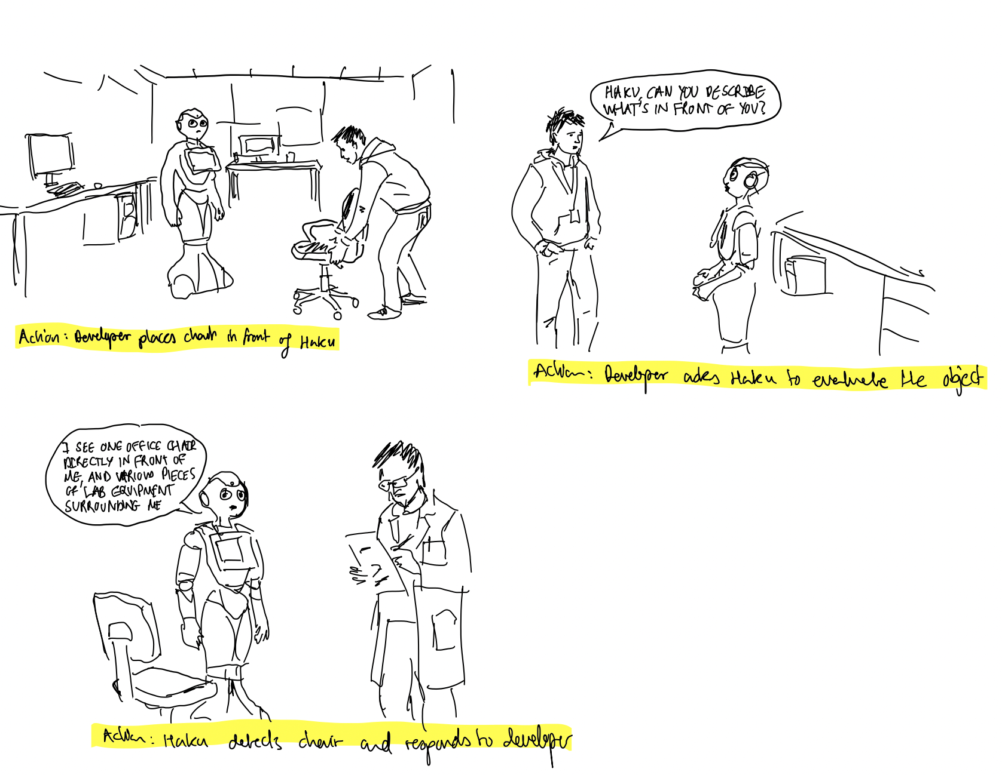

Storyboard 2: The Boundary Edge Case (Invalid Object)